**Build and deploy custom Connector**

1. Sign in to the PowerApps

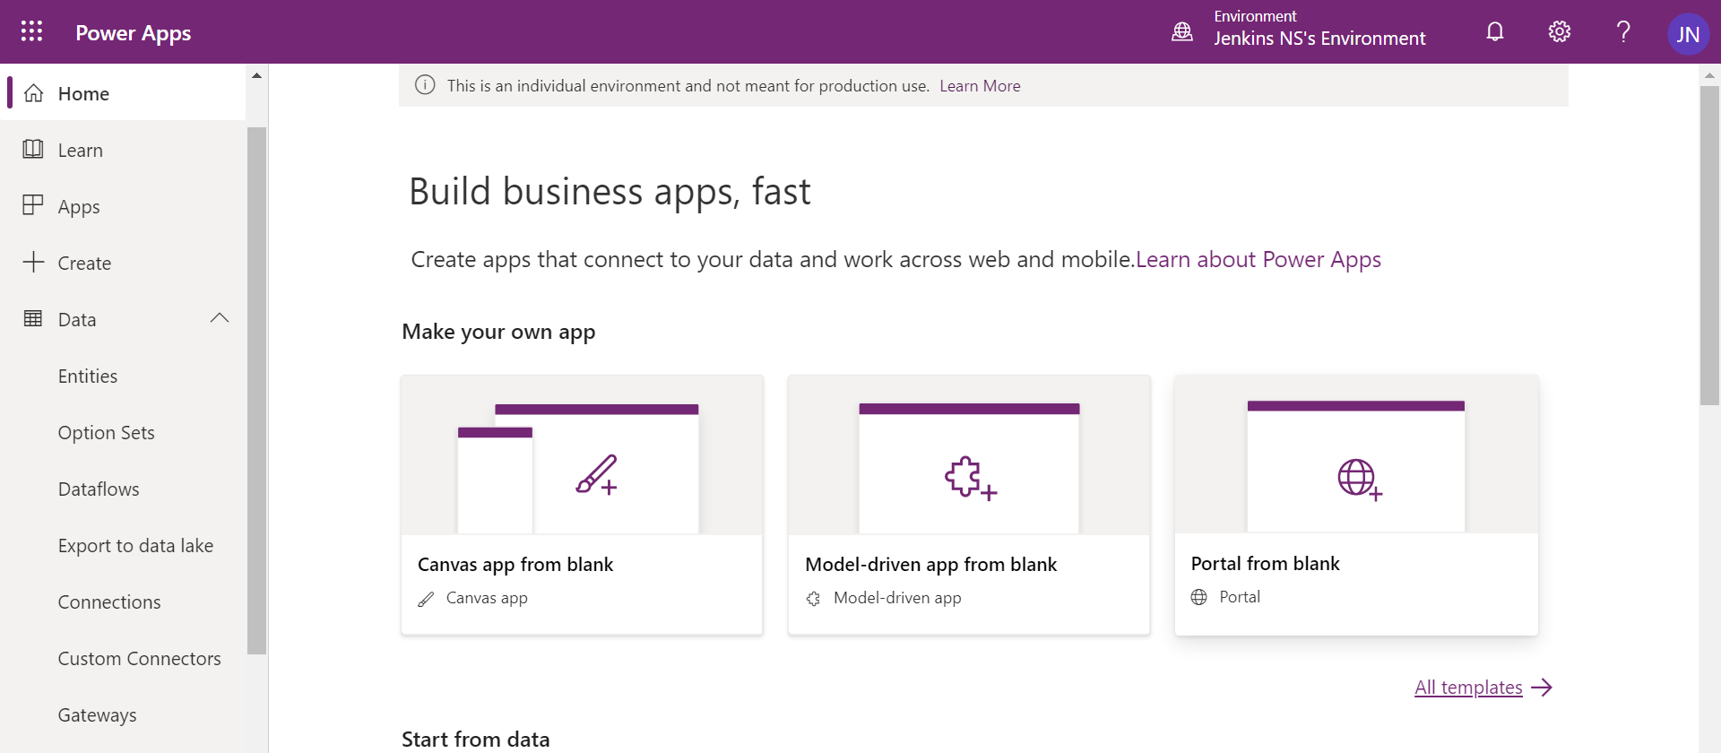

1. Click Custom Connectors under Data

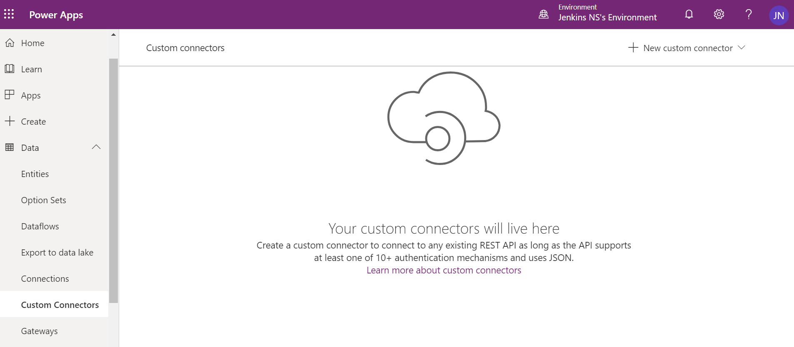

1. Click ‘New Custom connector’ in the right-hand side.

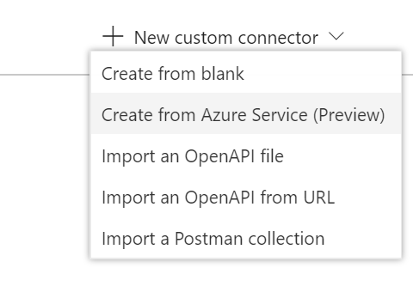

1. Select Create from blank
2. Give name for the connector
3. GetGoogleBooks

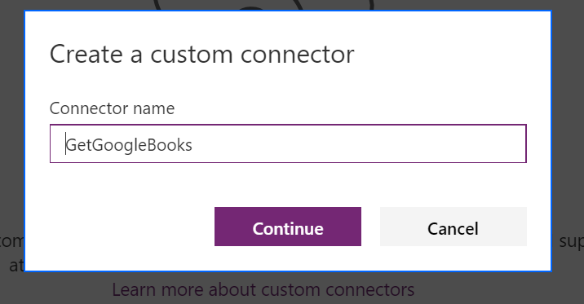

1. It will open Create connector page

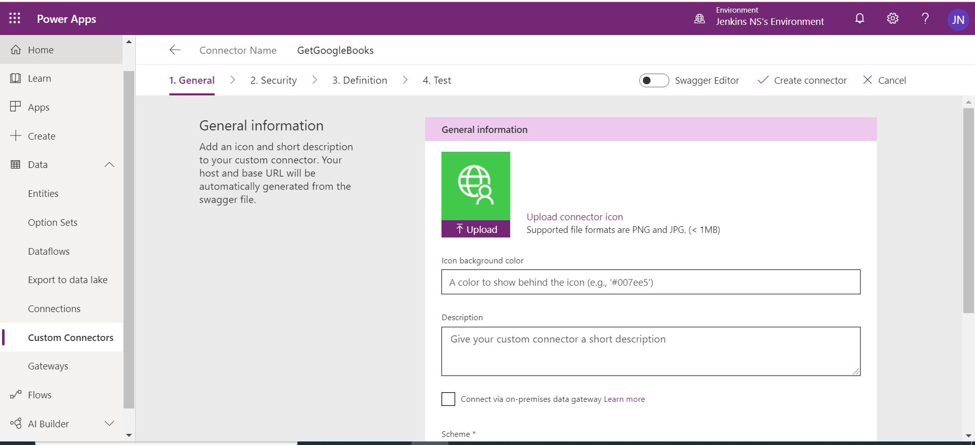

1. Fill the General Information
2. Upload logo for the connector
3. Set the background color
4. Give proper description about your connector

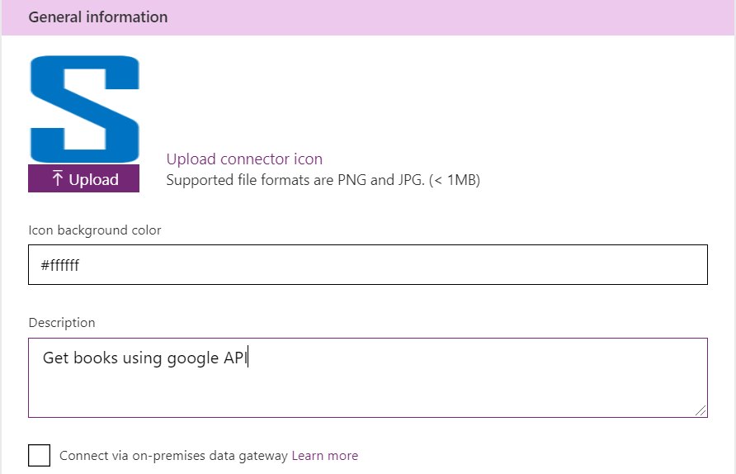

1. Scheme HTTPS
2. Host *: www.googleapis.com
3. Base URL: /books/

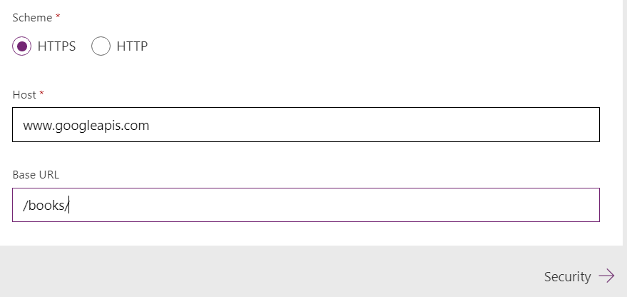

1. Click Security to move next section ‘Security’

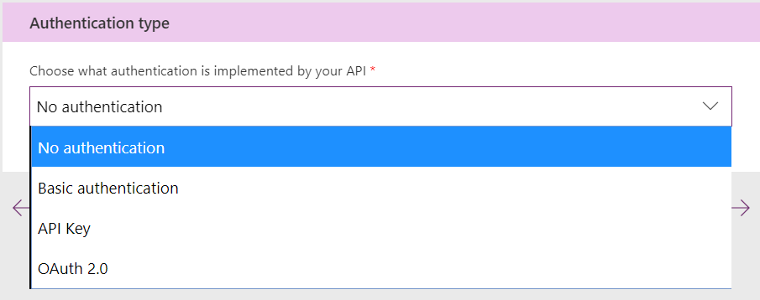

1. Select ‘No authentication’ for our lab exercise, because we are using open API
2. Click ‘Definition’ to move next section

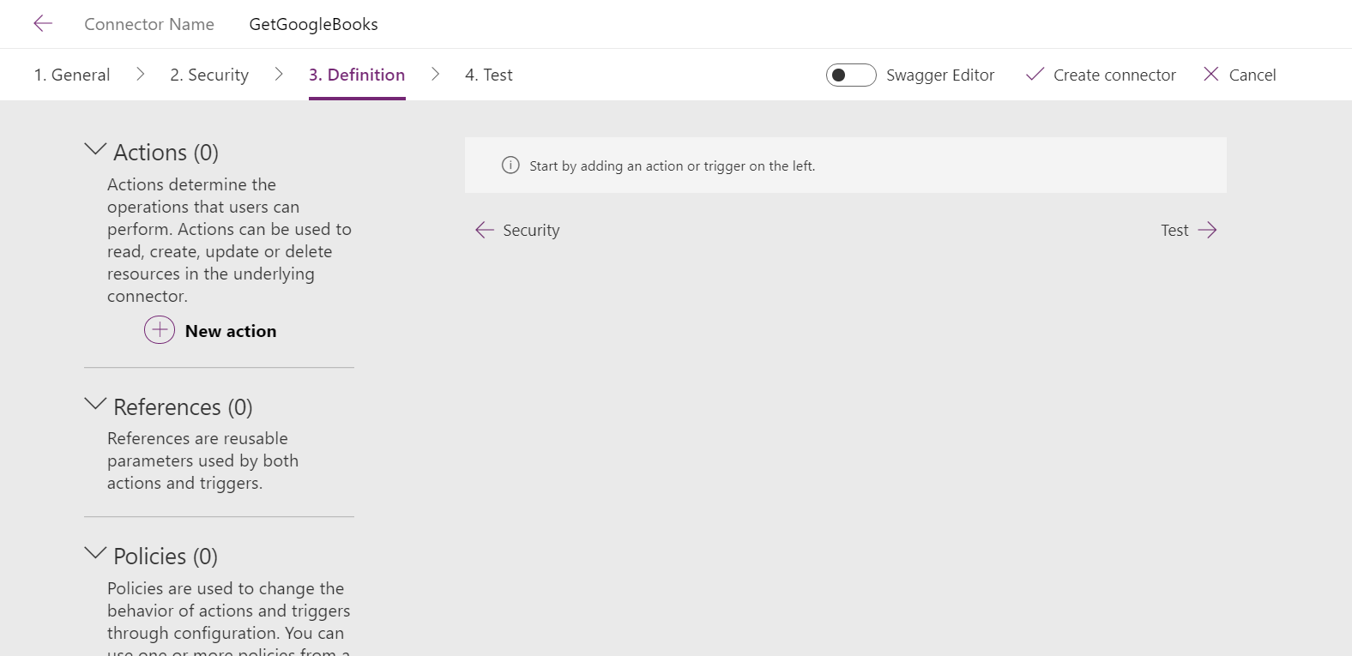

1. Add New Action
   1. Add Definition
      1. Summary: Get Books Names
      2. Description: get Books using google API
      3. Operation ID *: GetBooks
      4. visibility – none

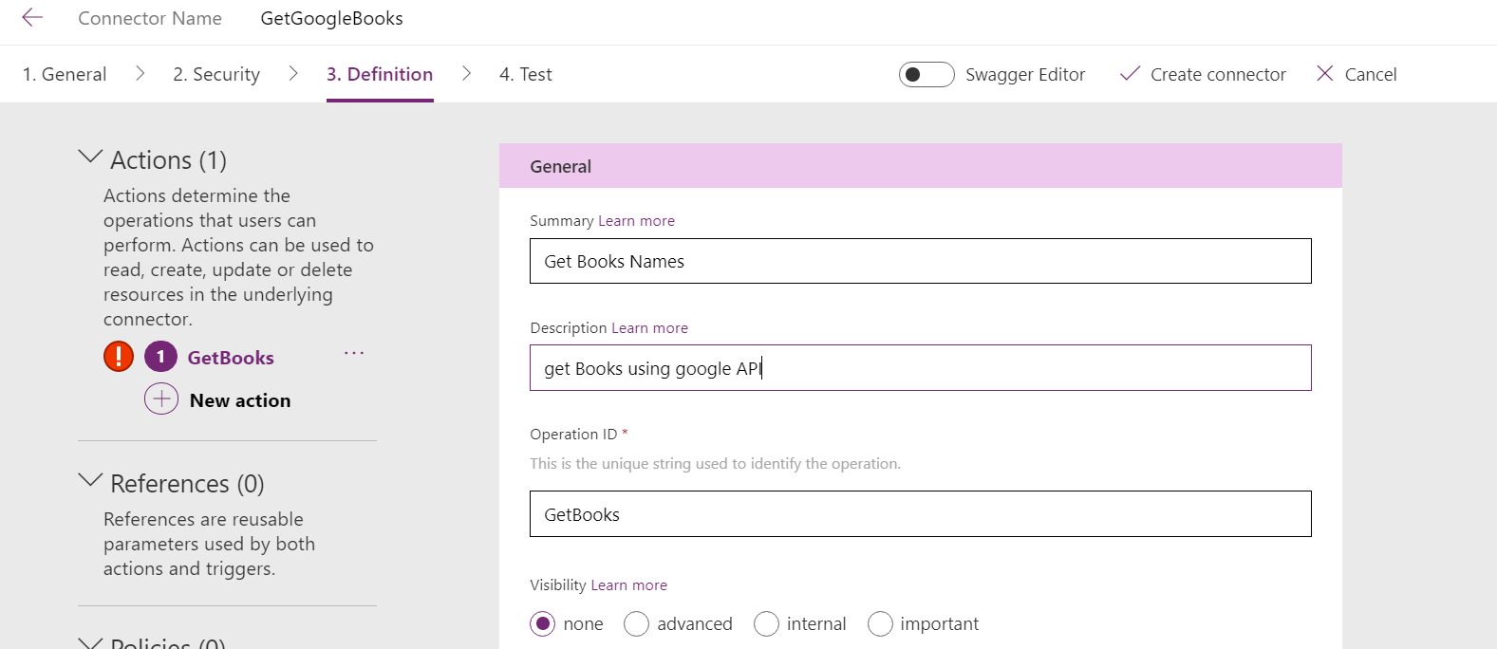

* 1. Add request - Click Import from sample
     1. Verb – Get
     2. Url- <https://www.googleapis.com/books/v1/volumes?q=>
     3. Click import to create request

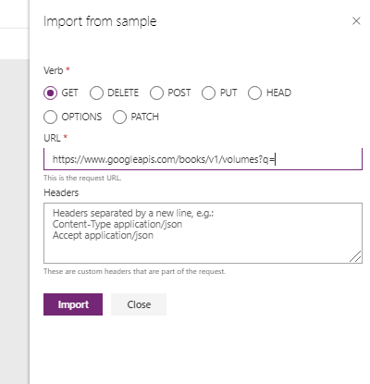

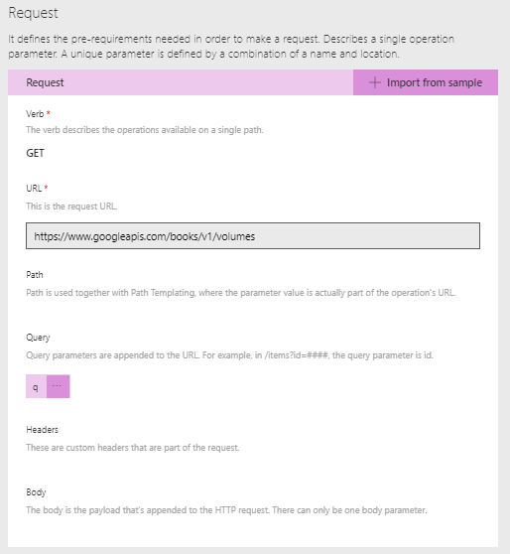

1. Add Response schema: Click default Response link

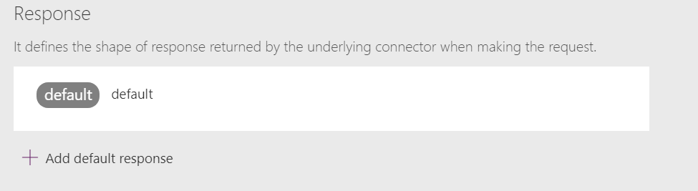

1. Click import from sample

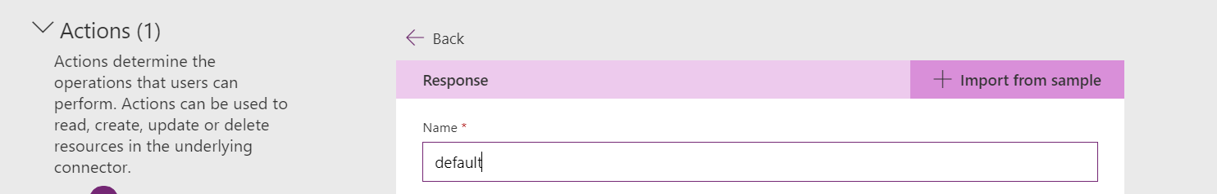

1. Open this URL in chrome browser and copy the whole response from the browser : <https://www.googleapis.com/books/v1/volumes?q=ISBN:9780789748591>
2. Paste in the body control

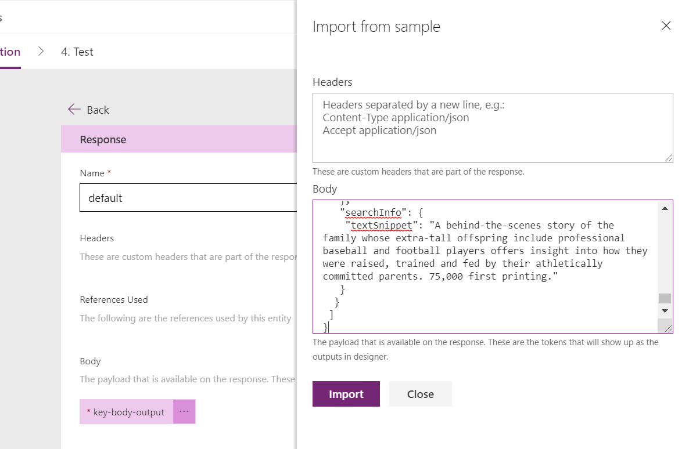

1. Click import and set schema to response

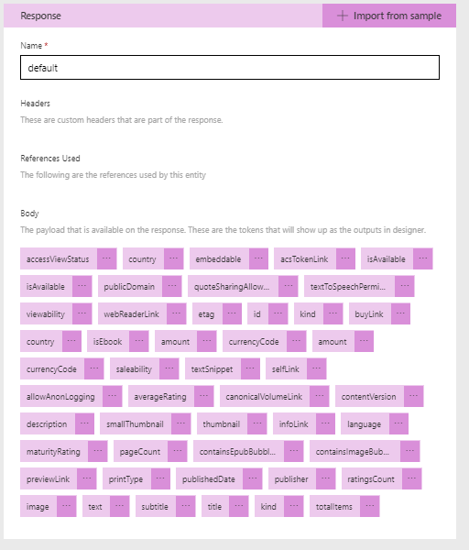

1. Click ‘Create connector’ to create the connector



1. Click Test to test the connector
   1. Create New connection

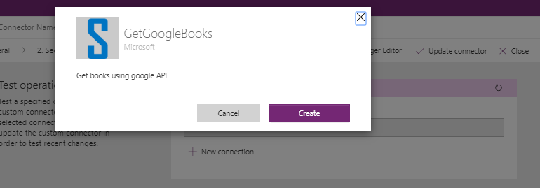

* 1. Test the connector give parameter : [ISBN:9780789748591](https://www.googleapis.com/books/v1/volumes?q=ISBN:9780789748591)

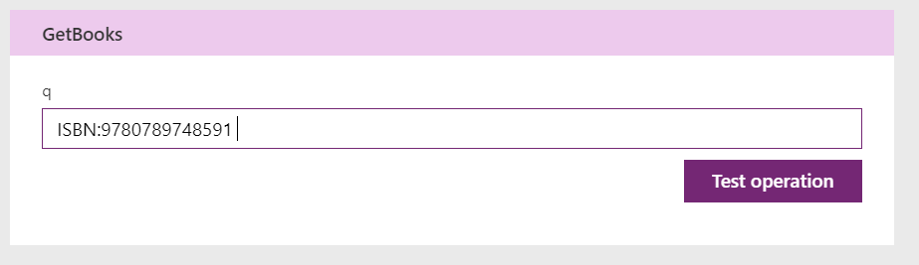

* 1. It will reply the response with 200 status

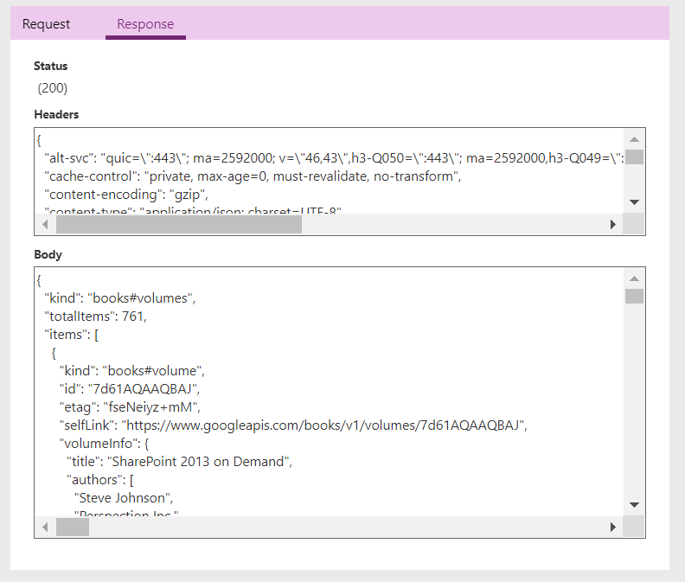

Implement custom connector in our canvas app

1. Create a canvas app

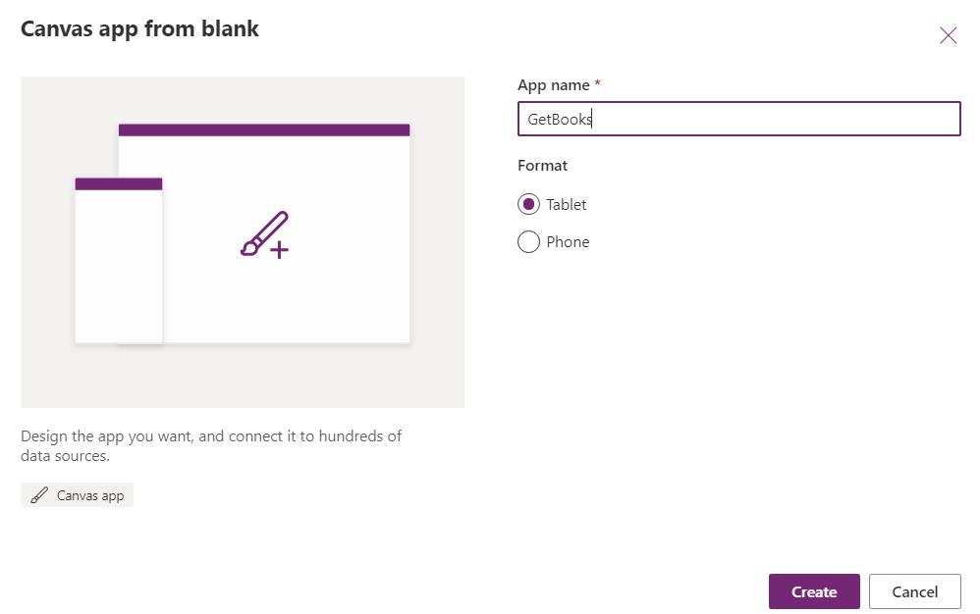

1. Click create button to create a application and skip button to skip the default form creation

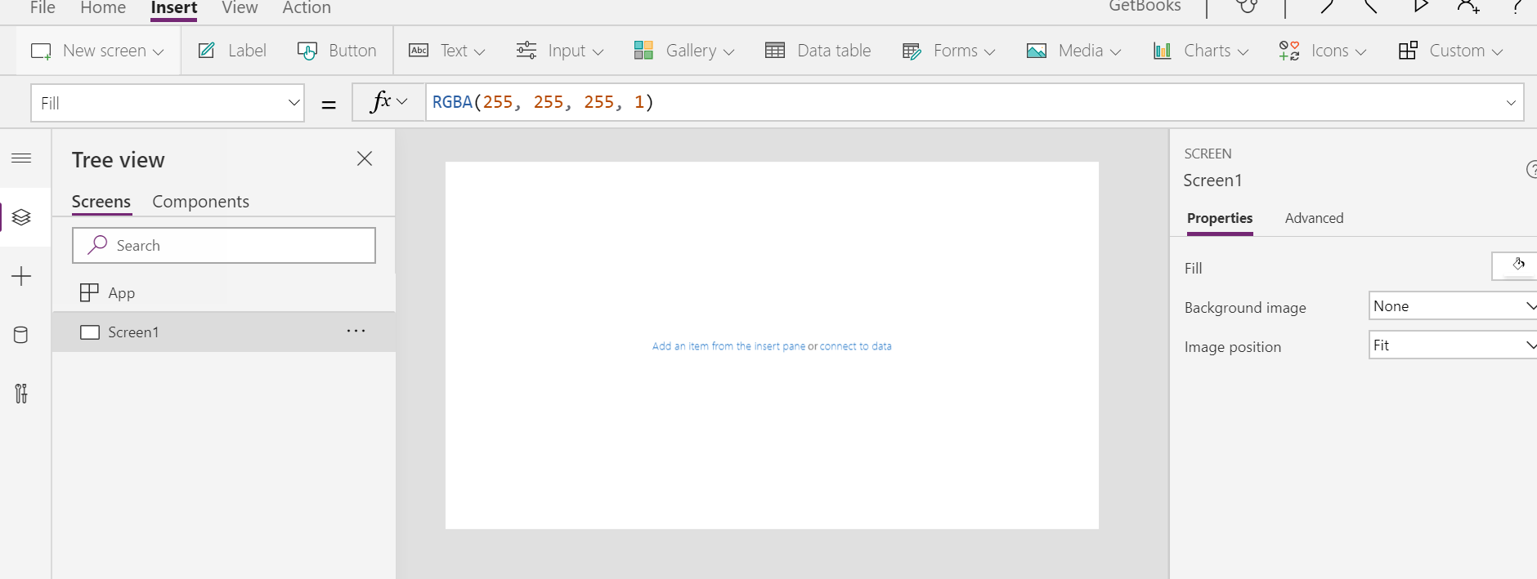

1. Click data source and connect your connector

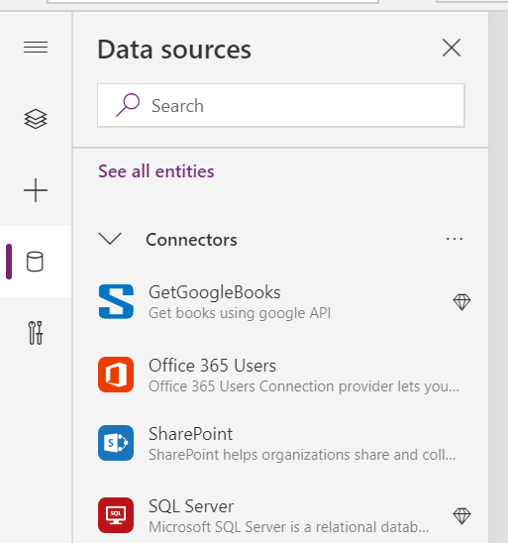

1. Select your connector ‘GetGoogleBooks’
2. Add Label Box – Enter ISBN Number
3. Add one Text Box
4. Add one Button
   1. Button OnSelect -> Clear**Collect(mybooks,GetGoogleBooks.GetBooks({q:TextInput1.Text}))**
5. Add vertical Gallery control with Image,title nd subtile
   1. Datasource - First(mybooks).items
   2. Image: ThisItem.volumeInfo.imageLinks.thumbnail
   3. Title: ThisItem.volumeInfo.title
   4. SubTitle: ThisItem.volumeInfo.description
6. Output here

